**Chapter 5**

**Osteoarthritis Classification using Knee X-ray Imagery:**

**The Graph Based Approach**

**5.1 Introduction**

The introduction of the graph-based approach for knee-OA classification is discussed in this chapter. As noted in Chapter 1 Section 1.3, there were two studies: (i) knee OA detection and (ii) knee-OA stage classification. Thus, these two studies are applied with respect to quadtree analysis.

The introduction of graph based approach applying for knee-OA detection and knee-OA stage classification are considered in this section. The major objective of the knee-OA detection study is to classify OA and normal control, while knee-OA stage classification work aims to classify the stage of knee-OA with 128 medical X-ray images presented in Chapter 3. The promoted idea of this section is illustrated the nature of each Whole knee and knee joint space X-ray image, using graph based representation. In term of training data, the graph based present of the dataset segmentation as whole knee segmentation and knee joint space segmentation. This training can then be applied to build a graph based classifier that can be used to analyses OA classification of image according to the nature of proposed graph structure representation.

To be more specific, the image decomposition approach is discussed where by the whole knee and knee joint space sub-image are presented using quadtree decomposition, both whole knee and joint space sub-image were presented in Section 3.4 of Chapter 3. In order to get the joint space more clear, the Otsu was applied to joint space sub-image. Thus, there three sub-set dataset for study. Once each set of sub-image has been fine segmented the next stage of the data preparation phase is to translate the segmented of each sub-image pixel dataset into a form of suitable for the application of classifier. The data translation need to be conducted in a way of better information is selected while in the intervening time ensuring that the representation is better enough to enable for effective further processing. The major idea of the study is to adopt the graph based representation, especially a quadtree representation (one per each sub-image). In case of medical image, work [59, 60] have been applied quadtree for the proposed study of medical image classification and segmentation. On the other hands, the quadtree representation does not depend on itself to ready incorporation with reference to learning methods. In order to do this, the subgraph mining was applied to the quadtree data to identify frequently subgraph which frequently occurring pattern across data that can be considered as feature in term of a feature vector representation. A proposed framework of graph based approach is given in Figure 6.1bellow:

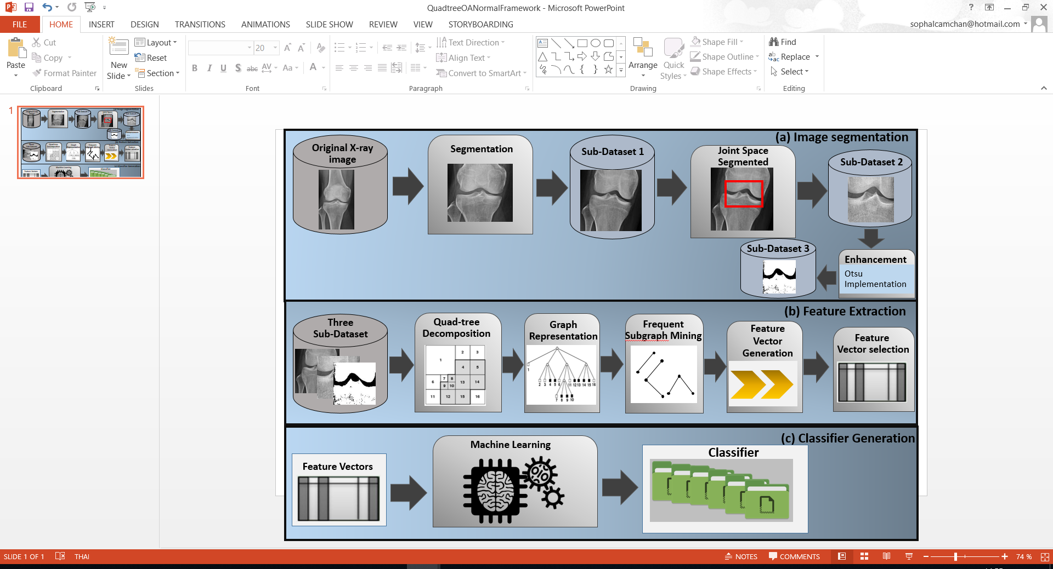

Figure 6.1 Framework illustrating Graph Based of OA detection

From the Figure 6.1, it can be seen that graph based of OA detection comprised of 3 main processes: (a) Image segmentation, (b) Feature Extraction, and (c) Classifier Generation. For the process of image segmentation and enhancement considered as the first process of the framework was presented in Chapter 3 and will thus not be considered more in this chapter. There are three sub-image dataset that got from the segmentation and enhancement process: (i) the whole knee sub-image, (ii) the joint space sub-image, and (iii) the enhancement of joint space sub-image (Otsu implementation). Once a dataset of each sub-image has been segmented, the next process refer to the feature extraction process, which used to translate the segmented image pixel data into an appropriated form suitable for classier generation (the third process of the study framework). The third process of the framework is little further consideration in this section.

In the feature extraction as presented in Figure 6.1 contained a number of sub-processes. The major idea of the processing is to apply the graph based approach which is used the quadtree based representation to each sub-image dataset. In this case, the group of subgraph that frequently happen in the data can be establish which can be applied with the reference to a feature vector representation of the form used by Bayesian and naïve bay classifiers. The sub-process that create the feature extraction process are comprised of five sub-processes: (i) quadtree decomposition, (ii) graph/tree representation, (iii) frequent subgraph mining, (iv) feature vector generation, and (v) feature selection.

The rest of this chapter is organised as follow: the information of quadtree decomposition is presented in Section 5.2, and Section 5.3 illustrates the tree/graph representation. The discussion of frequent subgraph mining is illustrated in Section 5.4, while the Section 5.5 presents the feature selection and classification. The evaluation of the chapter is illustrated in Section 5.6, for knee-OA detection evaluation is presented in Sub-section 5.6.1 and Sub-section 5.6.2 illustrates the knee-OA stage classification evaluated. The discussion of OA classification work is presented in Section 5.7. Finally, the chapter summary is presented in Section 5.8.

**5.2 Quadtree Decomposition**

In this sub-section the quadtree decomposition is presented, before go straight to quatree decomposition, the image decomposition need to be considered first. Image decomposition considers as the methodology for “factorising an input image in to a group of component” [61]. Image decomposition applications has been applied in various filed of: (i) image classification, (ii) Image segmentation, (iii) image recognition, (iv) image fusion, (v) computer vision, and (vi) motion estimation. The methodology of image decomposition comprise of (i) quadtree, (ii) wavelet, (iii) scale space, and (iv) pyramid (both Gaussian and Laplacian pyramid). To be more evidence of the methodology of image composition in term of medical image, work [62] have been applied wavelet parameter to MRI and CT images classification, in the study [63] have proposed the Laplacian pyramid for image fusion with the application of CT and MRI image.

In the context of digital image, the four method of image decomposition (quadtree, wavelet, scale space, pyramid) are presented above were proposed in works [65, 66] In this work refer to the applying of graph based approach to each sub-image. Quadtree decomposition is known as a technique of a hierarchical approach of decomposing in image that naturally depend on quadtree data structure. The most well-known application of quadtree decomposition is applie in region base quadtree, where each level of the quadtree decomposition decompose image in to quadrant (four equal regions) [64]. One problem that is consider as the most common issue of quadtree decomposition is the stopping of the level to be adopted. In order to solve this problem, the maximum level of decomposition is expressed.

In the context of the knee X-ray image data consider in this chapter a quadtree decomposition of region of interest was applied. Figure 5.2 presents the example of quadtree decomposition process. From Figure 5.2 it can be seen that there are four sub-images, the Figure 5.2 (a) - 5.2 (d). Figure 5.2(a) illustrates the original image, Figure 5.2(b) presents a 23 x 23 image binary array where ‘1s’ are pixel insight the region, while ‘0s” are the pixels outside the region. Figure 5.2(c) illustrates the result of applying Quadtree decomposition to the region. In the Quadtree storage, the whole image is represented as the root node, while the immediate child nodes of the root nodes each refers as a region quadrant. In Figure 5.2 illustrates the processes of quadtree decomposition, the process stops when the process arrives at the homogenous region (region consist of all black pixels or all white pixels). The quadtree decomposition of figure 5.2(c) is illustrated in Figure 5.2(d).

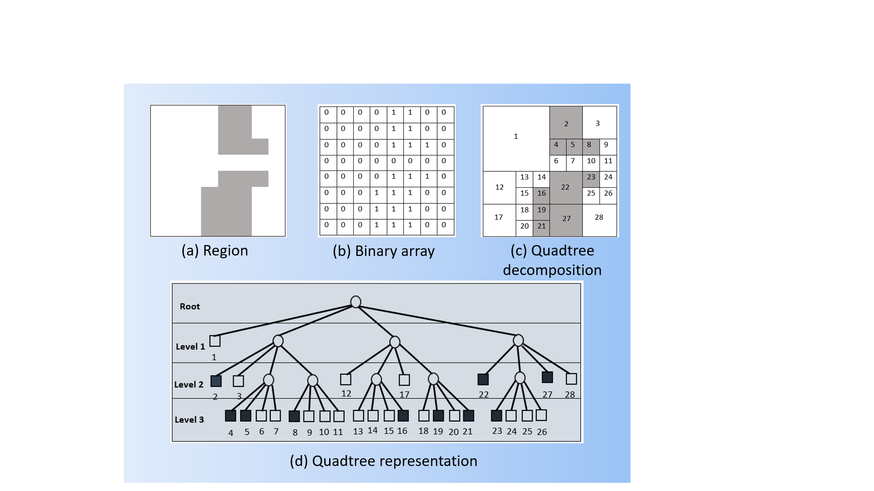

Figure 5.2: Quadtree decomposition

In case of medical image of knee X-ray image that applied graph-based approach to knee OA detection, the quadtree decomposition sub-process commences by cropping the region of interest to whole knee sub-image so that it is crop into a 128 x 128 pixel square image (the sub image is manually cropping). In Figure 5.3 is illustrated the process of quadtree decomposition to the whole knee sub image (Note that there are three sub image dataset were used in this chapter, the author picked up the whole knee sub image as an example). Figure 5.3(a) shows the original of whole knee sub image, while Figure 5.3(b) illustrates the quadtree decomposition of Figure 5.3(a).

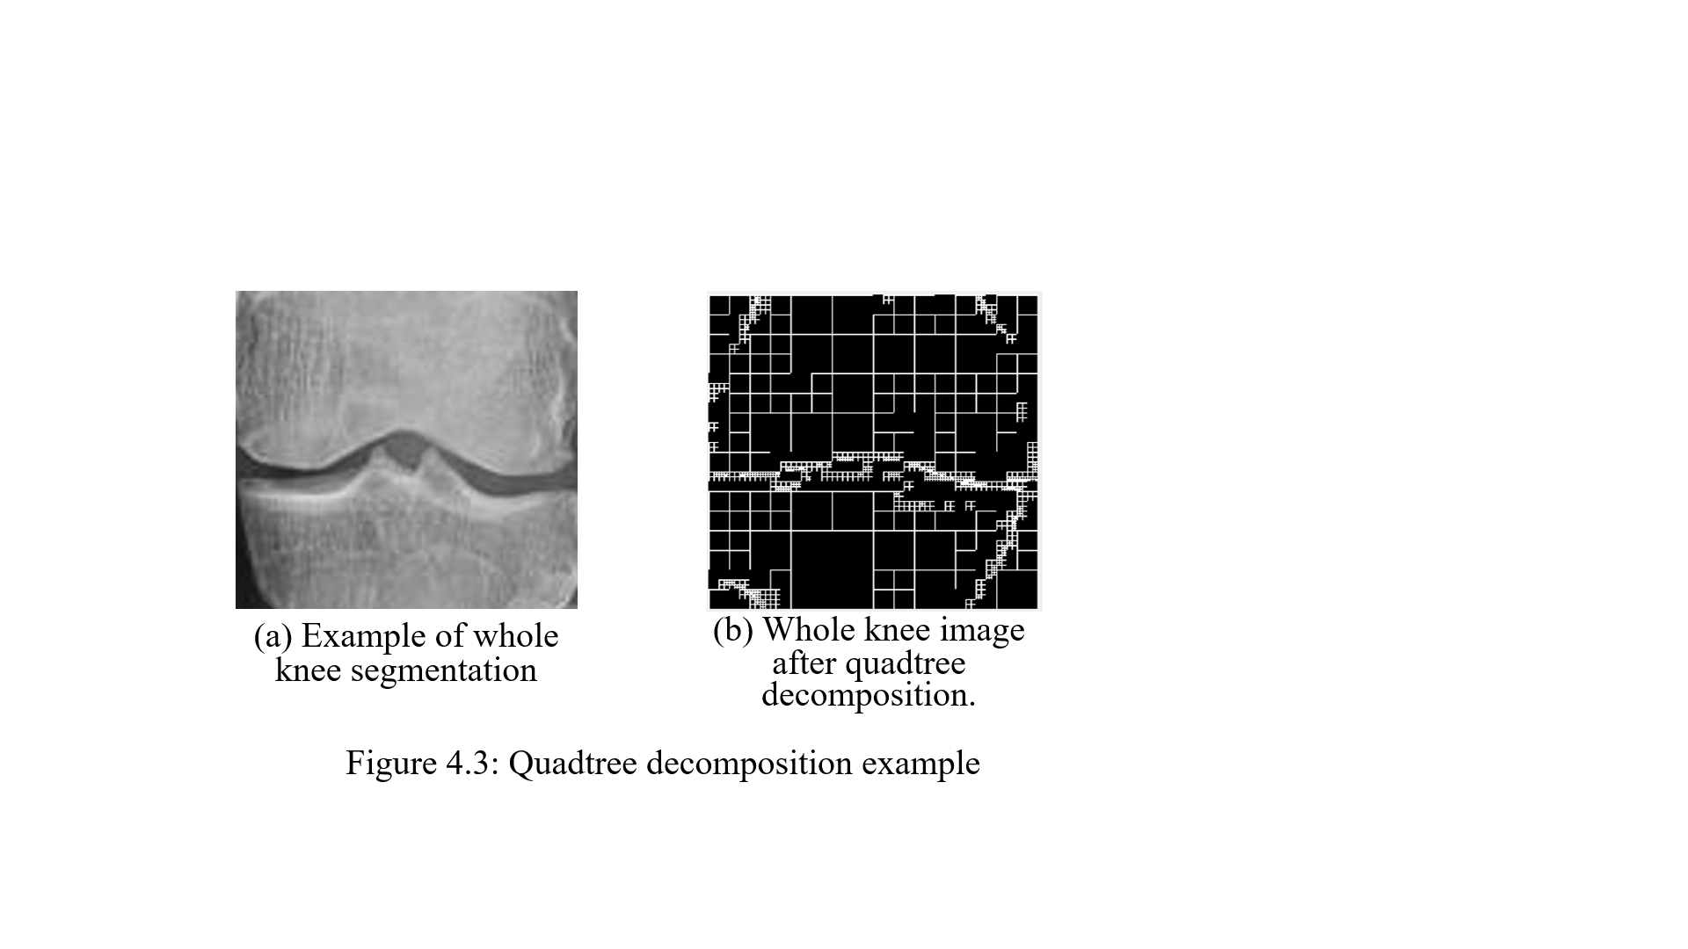

Figure 5.3 the example of Quadtree Decomposition to Whole knee sub-image

**5.3 Tree Representation**

Once the sub-image segmented have been decomposed and store in quadtree format, as describes in 5.2, The sub image was resized to 128 x 128 size, in this case eight labels were derived where each of label describe a range of 32 consecutive intensity value. Figure 5.4 is illustrated the example of quadtree representation where the root (top level node) represent as the whole knee sub image. In Figure 5.4 the next level of the root level is considered as the Level 1 is the root node’s immediate child nodes, and so on. From the root node or the parent node separates the edges into a set of identifiers 1, 2, 3, and 4 illustrating the NW, NE, SW, and SE. In Figure 5.4 illustrates that the number in square brackets alongside each node is a unique node identifier derived according to the decomposition.

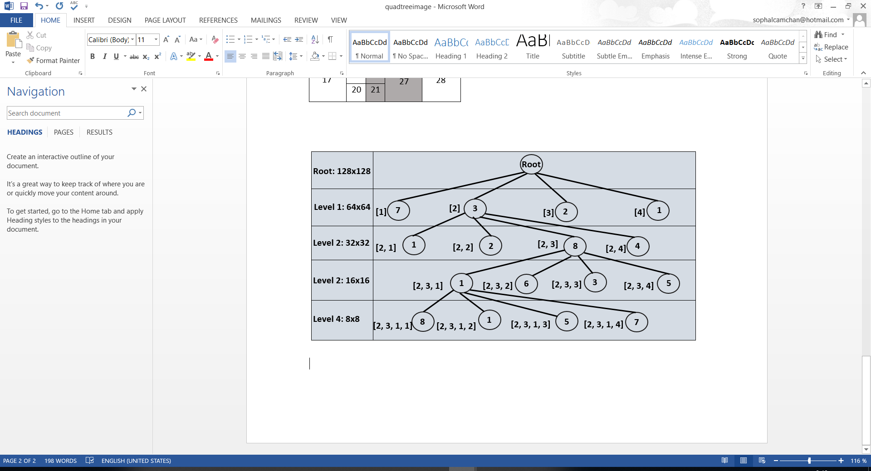

Figure 5.4 The implementation of Quadtree representation

**5.4 Frequent Subgraph Mining**

Frequent subgraph mining (FSM) is a technique of hierarchical decomposition image. The fundamental of FSM is to identify a group of feature which can used to create a feature vector representation.

In other words, FSM is well-known graph mining technique, FSM is the process of indicating the hidden information in graph data. Grap representation which is consider as a popular techniques of graph mining, are widely applied and work as the powerful and flexible approach for representing or modelling entities include chemical compounds, protein structure, circuit, biological network, work-flows, social networks, world wide web information, xml document and image data [67, 68]. For work chemical informatics, computer vision, video indexing and text retrieval were included in graph mining application [69, 70, 71, 72].

In this chapter, the graph mining which from SFM is the most appropriate technique to apply. Frequent subgrap mining is a famous graph mining technique which is mention in this study. Frequent subgrap is a technique to discover the graph that happen frequently, frequent subgraph may be used to: discriminate between different sets of graphs, characterise graph set, classify and cluster graphs, and facilitate similarity search in graph database. The work [67] and [73] have applied FSM for chemical analysis. FSM can be used with the reference to a collection of graphs or one single large graph, in the case of the this study, a collection of graphs representing the three different sub-image dataset (whole knee, knee joint space, and the implementation of Ostus to knee joint space sub-image dataset) segmented from the knee original image. Hence given a graph dataset D={G0, G1, …, Gn}, *support(g)* present the number of graphs (in D) in which a subgraph *g* exists. A subgraph *g* can be consider as the frequent if *support(g)* ≥ σ, where σ is a minimum support threshold.

The isomorphism testing is considered as the main component of FSM algorithm, it is the process of reviewing whether a subgraph *g i* is identical to a subgrap *g j* . Isomorphism is needed with reference to candidate and support counting. Isomorphism is the major computational overhead associated with FSM. The majority FSM algorithm seek to limit the amount of isomorphism that is require. Apriori-based Graph Mining (AGM) algorithm is the given example proposed in work [74], then develop to be the Frequent Subgraph Mining (FSM) presented in work [75] which the FSM based on the idea of using what the author refer to as the “adjacent representation” of graph and an “edge-growing” strategy. In work [76] presented both of AGM and FSM take advantage of the Apriori mechanism in case of frequent item set mining of tabular data, example, if a *k* edge subgraph is not frequent none of its *k+1* edge subgraph will be frequent. The SFM of Apriori style comprises into three steps: (i) candidate generation, (ii) support counting, and (iii) graph pruning based on the σ threshold value. In the time of candidate generation *k+1* edge candidate subgraph are generated from the frequent *k* edge subgraph identified on the previous iteration, a process called as *subgraph growing*.

Algorithm 1: The Process of Frequent Subgraph Mining

1: INPUT G = {G0, G1, …, Gn }, σ = threshold;

2: OUTPUT S = { S0, S1, …, Sn };

3: S = null;

4: k = 1;

5: Ck = all one edge candidate subgraph in G;

6: **loop**

7: L = set of occurrence count for each Gi Ck obtained using an isomorphism process, with one to one corresponding with Ck;

8: F = set of frequent subgraph in Ck, where for each gi Ck  1 L < σ;

9: S = S F;

10: k++

11: Ck = set of k edge subgraph extended from F using right most extension

12: if (k==null) then exit

13: **end loop**

The Algorithm 1 above describe the frequent subgraph process. In the algorithm, the input comprise of two variables: (i) a collection of graph (each graph represent an image) denote by G and (ii) the threshold value σ. A collection of frequent subgraph denoted by S is the outcome of the output. There are three parameter are used for the begins of the process: (i) the set of frequent subgraph is initially an empty set, (ii) the counter k is defined as 1, and (iii) the set of one edge candidate subgrap is defined as Ck. In the algorithm, there is one which is start from line 6 to line 13 through the following steps: (i) determine the occurrence count for each subgraph Gi Ck using an isomorphism process, (ii) compare the occurrence count of each subgraph Gi Gk with the σ and add those Gi whose occurrence count is greater than σ to the set F. (iii) add the set F to the set S, (iv) increment k and generate the next size of candidate sets Ck from F, and (v) do the the loop of the process again. The loop does until no more candidate can be generated (Ck =0).

In the study, graph representation have been applied to the three subimage of knee X-ray image contain of two main advantages: (i) the first advantage of the representation is the “boundary problem” where object of interest may be located at the intersection of a decomposition and (ii) the quadtree representation is not directly suited to use with classifier generation and subsequent usage of the generated classifier. Thus, the FSM have been applied for the purpose of this study to be considered as the feature within feature vector representation that is suitable to apply with classifier generation.

When the set of frequently has occurred, the frequently can be arranged into a feature vector representation, for each feature vector indicates the presence of a particular subgraph with the reference to each knee subimage as illustrated in Table 5.1. With the respect to the table each row refer to the individual subimage image knee data of each sub dataset (record from 1 to m), and the columns individual frequent subgraph present by set {S1, S2, …, Sn}. In the table row, the value 0 represent the absence and the value 1 indicate the presence of the associated subgraph for the record. The output of this process is the feature vector which can be apply for both classifier generation and the future usage of the generated classifier.

|  |  |  |  |  |  |  |  |
| --- | --- | --- | --- | --- | --- | --- | --- |
| Vector | S1 | S2 | S3 | S4 | S5 | …. | Sn |
| 1  2  3  …  m | 1  0  1  …  1 | 1  1  0  …  0 | 0  1  0  …  1 | 0  1  1  …  0 | 1  0  1  …  1 | …  …  …  …  … | 1  1  0  …  1 |

Table 5.1: The example of Feature Vector of Knee X-ray Image.

**5.5 Feature Selection and Classification**

When the feature vector generation was completed from the previous process, then the classification model generation could be consider. However, in order to generate the classification model, the input data need to be discretised (range). The challenge of the feature selection process is the large number of feature (subgraphs) identified. Feature selection have been applied to reduce the feature dimensionality whereby only highly discriminative features were retained. In this study, the Correlation-based Feature Selection (CFS) have been applied to feature evaluation measure for scoring feature. On the finishing of feature selection process, each subimage of each dataset was describe in term of a reduce number of features.

After the feature selection process was done, the next process is the classification process. The extensive evaluation was conducted so as to test operation of the different parameters and their variation, in this study only discuss the most significant results. With the reference to the evaluation in the next subsection, two well-known method of Bayesian Network and Naïve Bayes to the three different subdataset where each dataset was considered as Algorithm 1 (whole knee subimage dataset), Algorithm 2 (knee joint space subimage dataset), and Algorithm 3 ( the implementation of Otsu to knee joint space subimage dataset). For Bayesian Network and Naïve Bayes are taken from the Waikato Environment for Knowledge Analysis (WEKA) machine learning workbench.

**5.6 Evaluation**

**5.6.1 Osteoarthritis Detecting using Graph-based Analysis**

In this subsection, the evaluation of the knee OA detection by applying the graph based is presented. The evaluation was conducted to three subimage dataset presented in chapter3. With the implementation of CFS feature selection, the overall aim of prove that knee OA detection can be effective detected by using the proposed graph-based approach. To this end three set of experiments were conducted as follow:

1. Data Representation: A set of experiment to illustrate the most appropriate support threshold, σ, for used with reference to the frequent subgraph mining
2. The subimage dataset: A set of experiment to determine the most appropriate subimage amounts three sub-dataset to use with the frequent subgraph mining
3. Classification Generation Method: A set of experiment to identify the most appropriate classification generation method

Each criteria was mention above is discussed in detail in the indicate sub-section. Ten Cross-Validation (TCV) was applied in the study and the performance was recorded in term of: (i) Area Under ROC Curve (AUC), (ii) Accuracy (AC), (iii) Sensitivity (SN), (iv) Specificity (SP), (v) The F-Measure (FM), which presented in detail in Section 2.6. In this work, AUC was considered as the most significant measure to be used when comparing approach.

Before go forward the detail of each sub-section was mentioned above the whole result experiments are presented in Table 5.2- Table 5.7.

Algorithm1: Whole knee segmentation

1. Bayesian Network

|  |  |  |  |  |  |  |
| --- | --- | --- | --- | --- | --- | --- |
| **σ** | **AUC** | **AC** | **SN** | **SP** | **PR** | **FM** |
| σ= 10 | 0.892 | 0.789 | 0.789 | 0.785 | 0.803 | 0.788 |
| σ = 20 | 0.775 | 0.734 | 0.734 | 0.737 | 0.737 | 0.734 |
| σ= 30 | 0.745 | 0.719 | 0.719 | 0.719 | 0.719 | 0.719 |
| σ= 40 | 0.725 | 0.680 | 0.680 | 0.68 | 0.68 | 0.68 |
| σ= 50 | n/a | n/a | n/a | n/a | n/a | n/a |

Table 5.2 The result of Bayesian Network to Algorithm 1 Subimage

1. Naïve Bayes

|  |  |  |  |  |  |  |
| --- | --- | --- | --- | --- | --- | --- |
| **σ** | **AUC** | **AC** | **SN** | **SP** | **PR** | **FM** |
| σ= 10 | 0.895 | 0.789 | 0.789 | 0.785 | 0.803 | 0.788 |
| σ = 20 | 0.775 | 0.734 | 0.734 | 0.737 | 0.737 | 0.734 |
| σ= 30 | 0.745 | 0.727 | 0.727 | 0.727 | 0.727 | 0.727 |
| σ= 40 | 0.725 | 0.680 | 0.680 | 0.68 | 0.68 | 0.68 |
| σ= 50 | n/a | n/a | n/a | n/a | n/a | n/a |

Table 5.3 The result of Naïve Bayes to Algorithm 1

Algorithm 2: Knee Join Space segmentation

1. Bayesian Network

|  |  |  |  |  |  |  |
| --- | --- | --- | --- | --- | --- | --- |
| **σ** | **AUC** | **AC** | **SN** | **SP** | **PR** | **FM** |
| σ= 10 | 0.874 | 0.781 | 0.781 | 0.78 | 0.781 | 0.781 |
| σ = 20 | 0.792 | 0.719 | 0.719 | 0.712 | 0.722 | 0.719 |
| σ= 30 | 0.782 | 0.719 | 0.719 | 0.72 | 0.720 | 0.719 |
| σ= 40 | 0.743 | 0.727 | 0.727 | 0.727 | 0.727 | 0.727 |
| σ= 50 | 0.733 | 0.703 | 0.703 | 0.709 | 0.715 | 0.701 |

Table 5.4 The result of Bayesian Network to Algorithm 2 Sub-image

1. Naïve Bayes

|  |  |  |  |  |  |  |
| --- | --- | --- | --- | --- | --- | --- |
| **σ** | **AUC** | **AC** | **SN** | **SP** | **PR** | **FM** |
| σ= 10 | 0.877 | 0.781 | 0.781 | 0.78 | 0.781 | 0.781 |
| σ = 20 | 0.792 | 0.719 | 0.719 | 0.712 | 0.722 | 0.719 |
| σ= 30 | 0.782 | 0.719 | 0.719 | 0.72 | 0.720 | 0.719 |
| σ= 40 | 0.744 | 0.727 | 0.727 | 0.727 | 0.727 | 0.727 |
| σ= 50 | 0.732 | 0.703 | 0.703 | 0.709 | 0.715 | 0.701 |

Table 5.5 The result of Naïve Bayes to Algorithm 2 Sub-image

Algorithm 3: The implementation of Otsu to knee join space sub-image

1. Bayesian Network

|  |  |  |  |  |  |  |
| --- | --- | --- | --- | --- | --- | --- |
| **σ** | **AUC** | **AC** | **SN** | **SP** | **PR** | **FM** |
| σ= 10 | 0.915 | 0.828 | 0.828 | 0.826 | 0.829 | 0.828 |
| σ = 20 | 0.861 | 0.773 | 0.773 | 0.775 | 0.776 | 0.773 |
| σ= 30 | 0.823 | 0.742 | 0.742 | 0.742 | 0.742 | 0.742 |
| σ= 40 | 0.794 | 0.711 | 0.711 | 0.712 | 0.712 | 0.711 |
| σ= 50 | 0.740 | 0.703 | 0.703 | 0.704 | 0.704 | 0.703 |

Table 5.6 The result of Bayesian Network to Algorithm 3 Sub-image

1. Naïve Bayes

|  |  |  |  |  |  |  |
| --- | --- | --- | --- | --- | --- | --- |
| **σ** | **AUC** | **AC** | **SN** | **SP** | **PR** | **FM** |
| σ= 10 | 0.916 | 0.828 | 0.828 | 0.826 | 0.829 | 0.828 |
| σ = 20 | 0.861 | 0.773 | 0.773 | 0.775 | 0.776 | 0.773 |
| σ= 30 | 0.823 | 0.734 | 0.734 | 0.735 | 0.735 | 0.734 |
| σ= 40 | 0.794 | 0.711 | 0.711 | 0.712 | 0.712 | 0.711 |
| σ= 50 | 0.739 | 0.703 | 0.703 | 0.704 | 0.704 | 0.703 |

Table 5.7 The result of Navie Bayes to Algorithm 2 Sub-image

1. Data Representation

In this sub-section, the most appropriate support threshold (σ) values that drive the best result to the experiments are presented. In term of support threshold value, the study have been focused on five different values of σ, for instance: σ =10, σ=20, σ=30, σ=40, and σ=50. With the respect to the research experiments presented in Table 5.2-Table 5.7, the best result experiments of each support threshold value is illustrated in Table 5.8 below:

|  |  |  |  |  |  |  |
| --- | --- | --- | --- | --- | --- | --- |
| **σ** | **AUC** | **AC** | **SN** | **SP** | **PR** | **FM** |
| σ= 10 | 0.916 | 0.828 | 0.828 | 0.826 | 0.829 | 0.828 |
| σ = 20 | 0.861 | 0.773 | 0.773 | 0.775 | 0.776 | 0.773 |
| σ= 30 | 0.823 | 0.734 | 0.734 | 0.735 | 0.735 | 0.734 |
| σ= 40 | 0.794 | 0.711 | 0.711 | 0.712 | 0.712 | 0.711 |
| σ= 50 | 0.740 | 0.703 | 0.703 | 0.704 | 0.704 | 0.703 |

Table 5.8 The best result of support threshold value of the research

From Table 5.8 it can be seen that the best result of the experiment from the support threshold value of σ =10 with the AUC value of 0.916, then the second best result and the third best result are indicated by the value of σ =20 and σ=30 with the AUC vale of 0.861 and 0.823 respectively. It should be noted that knee OA detection in term of graph based approach of applying quadtree the best suitable support threshold value of 10.

1. The Subimage Dataset

The best result of the three different of subimage dataset were applied in the study is presented in this sub-section. Once again, the three subimage were applied include: (i) whole knee subimage were considered as the Algorithm 1 subimage, (ii) knee joint space subiamage were considered as the Algorithm 2 subimage, and (iii) the implementation of Otsu to Algorithm 2 subimage were consideres as the Algorithm 3 subinage. The best result experiment of each subimage is presented in Table 5.9:

|  |  |  |  |  |  |  |
| --- | --- | --- | --- | --- | --- | --- |
| **SubImage** | **AUC** | **AC** | **SN** | **SP** | **PR** | **FM** |
| Algorithm 1 | 0.895 | 0.789 | 0.789 | 0.785 | 0.803 | 0.788 |
| Algorithm 2 | 0.877 | 0.781 | 0.781 | 0.78 | 0.781 | 0.781 |
| Algorithm 3 | 0.916 | 0.828 | 0.828 | 0.826 | 0.829 | 0.828 |

Table 5.9 The best result of the three subimage of the research

With the reference to table 5.9 illustrated that the applying of Otsu’s method to the knee joint space subimage (Algorithm 3 subimage) produce the best record of the research experiment with the AUC record of 0.916. In the same time, the whole knee segmented image (Algorithm 1 subimage) produced the second best result with the AUC value of 0.895. It should be suggested that the applying od Otsu to knee joint space segmented image works perfectly on knee OA detection in this research study.

1. Classification Generation Method

In this sub-section the best result of experiment of the two main classification generation methods are illustrated. The Bayesian Network and Naïve Bayes where applied in the study where the best result of each method are presented in Table 5.10:

|  |  |  |  |  |  |  |
| --- | --- | --- | --- | --- | --- | --- |
| Learning Method | AUC | AC | SN | SP | PR | FM |
| Bayesian Network | 0.915 | 0.828 | 0.828 | 0.826 | 0.829 | 0.828 |
| Naïve Bayes | 0.916 | 0.828 | 0.828 | 0.826 | 0.829 | 0.828 |

Table 5.10 The best result of the three subimage of the research

In Table 5.10 above illustrated that both Bayesian Network and Naïve Bayes method can produce the result slightly different in term of AUC value, but in term of AC, SN, SP, PR, and FM, Naïve Bayes and Bayesian Network produced the same result. It should be noted that both Bayesian Network and Naïve Bayes work well for knee OA detection in case of quadtree implementation.

**5.6.2 Osteoarthritis Stage Classification using Graph-based Analysis**

In this subsection, the evaluation of the knee OA stages classification by applying the graph based is illustrated. The evaluation was conducted to three subimage dataset mentioned in chapter3. With the respect of CFS feature selection applying, the overall aim of prove that knee OA stages classification can be effective detected by using the proposed graph-based approach. To this end three set of experiments were conducted as follow:

1. Data Representation: A set of experiment to define the most appropriate support threshold, σ, for used with reference to the frequent subgraph mining
2. The subimage dataset: A set of experiment to identify the most appropriate subimage amounts three sub-dataset to use with the frequent subgraph mining
3. Classification Generation Method: A set of experiment to select the most appropriate classification generation method

Each criteria was mention above is discussed in detail in the indicate sub-section. Ten Cross-Validation (TCV) was applied in the study and the performance was recorded in term of: (i) Area Under ROC Curve (AUC), (ii) Accuracy (AC), (iii) Sensitivity (SN), (iv) Specificity (SP), (v) The F-Measure (FM), which presented in detail in Section 2.6. In this work, AUC was considered as the most significant measure to be used when comparing approach.

Before go forward the detail of each sub-section was mentioned above the whole result experiments are presented in Table 5.11- Table 5.16

Algorithm1: Whole knee segmentation

1. Bayesian Network

|  |  |  |  |  |  |  |
| --- | --- | --- | --- | --- | --- | --- |
| σ | AUC | AC | SN | SP | PR | FM |
| σ= 10 | 0.778 | 0.508 | 0.508 | 0.821 | 0.502 | 0.500 |
| σ = 20 | 0.718 | 0.453 | 0.453 | 0.809 | 0.430 | 0.438 |
| σ= 30 | 0.695 | 0.477 | 0.477 | 0.815 | 0.453 | 0.462 |
| σ= 40 | 0.669 | 0.422 | 0.422 | 0.779 | n/a | n/a |
| σ= 50 | 0.592 | 0.352 | 0.352 | 0.726 | 0.298 | 0.306 |

Table 5.11 The result of Bayesian Network to Algorithm 1 Subimage of Knee OA Stages Classification

1. Naïve Bayes

|  |  |  |  |  |  |  |
| --- | --- | --- | --- | --- | --- | --- |
| σ | AUC | AC | SN | SP | PR | FM |
| σ= 10 | 0.770 | 0.508 | 0.508 | 0.824 | 0.498 | 0.499 |
| σ = 20 | 0.717 | 0.461 | 0.461 | 0.81 | 0.438 | 0.444 |
| σ= 30 | 0.696 | 0.477 | 0.477 | 0.815 | 0.453 | 0.462 |
| σ= 40 | 0.669 | 0.414 | 0.414 | 0.775 | n/a | n/a |
| σ= 50 | 0.593 | 0.359 | 0.359 | 0.727 | n/a | n/a |

Table 5.12 The result of Naïve Bayes to Algorithm 1 Subimage of Knee OA Stages Classification

Algorithm 2: Knee Join Space segmentation

1. Bayesian Network

|  |  |  |  |  |  |  |
| --- | --- | --- | --- | --- | --- | --- |
| σ | AUC | AC | SN | SP | PR | FM |
| σ= 10 | 0.803 | 0.539 | 0.539 | 0.829 | 0.532 | 0.531 |
| σ = 20 | 0.673 | 0.430 | 0.430 | 0.799 | 0.413 | 0.414 |
| σ= 30 | 0.663 | 0.461 | 0.461 | 0.819 | 0.461 | 0.453 |
| σ= 40 | 0.655 | 0.461 | 0.461 | 0.797 | 0.446 | 0.437 |
| σ= 50 | n/a | n/a | n/a | n/a | n/a | n/a |

Table 5.13 The result of Bayesian Network to Algorithm 2 Subimage of Knee OA Stages Classification.

1. Naïve Bayes

|  |  |  |  |  |  |  |
| --- | --- | --- | --- | --- | --- | --- |
| σ | AUC | AC | SN | SP | PR | FM |
| σ= 10 | 0.791 | 0.531 | 0.531 | 0.826 | 0.518 | 0.519 |
| σ = 20 | 0.676 | 0.430 | 0.430 | 0.799 | 0.413 | 0.414 |
| σ= 30 | 0.663 | 0.461 | 0.461 | 0.819 | 0.461 | 0.453 |
| σ= 40 | 0.654 | 0.453 | 0.453 | 0.791 | 0.430 | 0.424 |
| σ= 50 | n/a | n/a | n/a | n/a | n/a | n/a |

Table 5.14 The result of Naïve Bayes to Algorithm 2 Subimage of Knee OA Stages Classification.

Algorithm 3: The implementation of Otsu to knee join space subimage

1. Bayesian Network

|  |  |  |  |  |  |  |
| --- | --- | --- | --- | --- | --- | --- |
| σ | AUC | AC | SN | SP | PR | FM |
| σ= 10 | 0.851 | 0.609 | 0.609 | 0.857 | 0.611 | 0.608 |
| σ = 20 | 0.765 | 0.484 | 0.484 | 0.814 | 0.485 | 0.484 |
| σ= 30 | 0.759 | 0.477 | 0.477 | 0.814 | 0.486 | 0.475 |
| σ= 40 | 0.733 | 0.445 | 0.445 | 0.808 | 0.430 | 0.432 |
| σ= 50 | 0.680 | 0.422 | 0.422 | 0.817 | 0.430 | 0.419 |

Table 5.15 The result of Bayesian Network to Algorithm 3 Subimage of Knee OA Stages Classification.

1. Naïve Bayes

|  |  |  |  |  |  |  |
| --- | --- | --- | --- | --- | --- | --- |
| Min Support | AUC | AC | SN | SP | PR | FM |
| σ= 10 | 0.845 | 0.594 | 0.594 | 0.851 | 0.592 | 0.590 |
| σ = 20 | 0.762 | 0.477 | 0.477 | 0.815 | 0.475 | 0.474 |
| σ= 30 | 0.76 | 0.477 | 0.477 | 0.819 | 0.487 | 0.472 |
| σ= 40 | 0.733 | 0.445 | 0.445 | 0.808 | 0.430 | 0.432 |
| σ= 50 | 0.680 | 0.438 | 0.438 | 0.819 | 0.438 | 0.430 |

Table 5.16 The result of Naïve Bayes to Algorithm 3 Subimage of Knee OA Stages Classification.

1. Data Representation

In this sub-section, the most appropriate support threshold (σ) values that bring the best result to the experiments are illustrated. In the study of support threshold value, the study have been focused on five different values of σ, for instance: σ =10, σ=20, σ=30, σ=40, and σ=50. With the reference to the research experiments presented in Table 5.11-Table 5.16, the best result experiments of each support threshold value is illustrated in Table 5.17:

|  |  |  |  |  |  |  |
| --- | --- | --- | --- | --- | --- | --- |
| **σ** | **AUC** | **AC** | **SN** | **SP** | **PR** | **FM** |
| σ= 10 | 0.851 | 0.609 | 0.609 | 0.857 | 0.611 | 0.608 |
| σ = 20 | 0.765 | 0.484 | 0.484 | 0.814 | 0.485 | 0.484 |
| σ= 30 | 0.76 | 0.477 | 0.477 | 0.819 | 0.487 | 0.475 |
| σ= 40 | 0.733 | 0.445 | 0.445 | 0.808 | 0.430 | 0.432 |
| σ= 50 | 0.680 | 0.438 | 0.438 | 0.819 | 0.438 | 0.430 |

Table 5.17 The best result of support threshold value of the research

From Table 5.17 it can be illustrated that the best result of the experiment from the support threshold value of σ =10 with the AUC value of 0.851, then the second best result and the third best result are indicated by the value of σ =20 and σ=30 with the AUC vale of 0.765 and 0.760 respectively. It should be suggested that knee OA stages classification study in term of graph based approach of applying quadtree the best suitable support threshold value of 10.

1. The Subimage Dataset

The most appropriate ROIs or subimage of the three different of subimage dataset were applied in the study is presented in this sub-section. The three ROIs or subimage were applied include: (i) whole knee subimage were considered as the Algorithm 1 subimage, (ii) knee joint space subiamage were considered as the Algorithm 2 subimage, and (iii) the implementation of Otsu to Algorithm 2 subimage were consideres as the Algorithm 3 subinage. The best result experiment of each most appropriate subimage is presented in Table 5.18:

|  |  |  |  |  |  |  |
| --- | --- | --- | --- | --- | --- | --- |
| **SubImage** | **AUC** | **AC** | **SN** | **SP** | **PR** | **FM** |
| Algorithm 1 | 0.778 | 0.508 | 0.508 | 0.824 | 0.502 | 0.500 |
| Algorithm 2 | 0.803 | 0.539 | 0.539 | 0.829 | 0.532 | 0.531 |
| Algorithm 3 | 0.851 | 0.609 | 0.609 | 0.857 | 0.611 | 0.608 |

Table 5.18 The best result of the three subimage of the research

From table 5.18 it can be seen that the applying of Otsu’s method to the knee joint space subimage (Algorithm 3 subimage) produce the best record of the Knee OA stages classification research experiment with the AUC record of 0.851. For the best second appropriate subimage went to the knee joint space segmented image (Algorithm 2 subimage) produced the second best result with the AUC value of 0.803. It should be suggested that the applying of Otsu to knee joint space segmented image works perfectly on knee OA stage detection study.

1. Classification Generation Method

In this sub-section the most efficiency result of the two main classification generation methods are illustrated. The Bayesian Network and Naïve Bayes where applied in the study of knee OA stages classification where the best result of each method are presented in Table 5.19:

|  |  |  |  |  |  |  |
| --- | --- | --- | --- | --- | --- | --- |
| Learning Method | AUC | AC | SN | SP | PR | FM |
| Bayesian Network | 0.851 | 0.609 | 0.609 | 0.857 | 0.611 | 0.608 |
| Naïve Bayes | 0.845 | 0.594 | 0.594 | 0.851 | 0.592 | 0.590 |

Table 5.19 The best result of the three subimage of the research

In Table 5.19 illustrated that Bayesian Network produced a better performance than Naïve Bayes method. The Bayesian Network produced the result with AUC value of 0.851, while Naïve Bayes produced the result with AUC value of 0.845. It should be noted that both Bayesian Network and Naïve Bayes work well for knee OA stages detection in case of quadtree implementation due to the AUC value of the two learning method produce a slightly different.

**5.7 Discussion**

The discussion of knee-OA detection and knee-OA stage classification using quadtree analysis are presented in this section. As noted to the previous section of this chapter, there were 2 study of OA classification studies: (i) knee-OA detection and (ii) knee-OA stage classification.

As noted in the knee-OA detection result in the previous section illustrated that the proposed of quadtree applying in term of graph base approach, using quadtree analysis to three different subimage, performed well to the knee X-ray image dataset. The main finding from the knee-OA detection study experiment were divided into three sets:

1. Amount of five support threshold value (σ), the performance of σ value of 10 (σ=10) is better than other support threshold values performance that can make the classification is more effective. In term of AUC value measure, the report of evaluation found that σ=10 value produce AUC value of 0.916 considered as the highest value.
2. The most appropriate subimage of ROIs experiment of the study was obtain by the subimage of the applying Otsu to knee joint space subimage (Algorithm 3 subimage) with the highest AUC value of 0.916, followed by the whole knee segmenated image (Algorithm 1 subimage) with the AUC value of 0.877.
3. The best performance of leaning method identified from the reported evaluation were: Naïve Bayes and Bayesian Network, which considered as the top performance of learning method with the AUC value of 0.916 and 0.915 respectively, thus Naïve Bayes produced a slightly better overall performance than Bayesian Network.

With knee-OA stage classification presented in the Sub-section 5.6.2 of this chapter, The overall classification result of OA stages detection presented in the previous section, section 6.3.6 illustrated that the proposed of graph base approach, using quadtree analysis to three different subimage, and the proposed work smoothly to the knee X-ray image dataset. The main finding from the experiment were divided into three sets:

1. Amount of five support threshold value (σ), for example σ=10, 20, 30, 40 and 50, the performance of σ value of 10 (σ=10) is better than other support threshold values performance that can make the classification is more effective. In term of AUC value measure, the report of evaluation found that σ=10 value produce AUC value of 0.851 considered as the highest value.
2. The most appropriate subimage of ROIs experiment of the knee OA stages classification study was obtain by the subimage of the applying Otsu to knee joint space subimage (Algorithm 3 subimage) with the highest AUC value of 0.851, followed by the whole knee segmenated image (Algorithm 1 subimage) with the AUC value of 0.803.
3. The best performance of leaning method identified from the reported evaluation were: Naïve Bayes and Bayesian Network, which considered as the top performance of learning method with the AUC value of 0.851and 0.845 respectively, thus Naïve Bayes produced a slightly better overall performance than Bayesian Network in term of knee OA stages detection.

In conclusion, the discussion of OA classification studies using quadtree analysis is presented in this section. With the respect to the discussion of each study mentioned above, the main findings of the whole chapter were comprised into three sets of experiment:

1. In OA detection study the most appropriated support threshold value (σ), that drive the learning to get the best performance, was given by threshold value of 10 (σ=10). For the OA stages detection study, the threshold value of 10 can drive the study to get the best performance of classification. Thus, it can be notified that the support threshold value of 10 can performance well for both knee OA and knee OA stages classification study.
2. The best performance of graph based study on region of interest (ROIs) to be considered that the most appropriated ROI for both studies. In OA detection study and knee OA stage classification study, presented that the most appropriate ROI performed by Algorithm 3 that can drives both studies to get the best result was recorded. It can be concluded that the clearness on joint space image can produced the well performance of knee OA detection and knee OA stages classification study.
3. The most appropriated learning method between Naïve Bayes and Bayesian Network method. As the record of knee OA detection study presented that both Naïve Bayes and Bayesian Network are well performed for learning classification, while in knee OA stages classification study illustrated that Naïve Bayes was slightly better performance that Bayesian Network. It can be noted that both Naïve Bayes and Bayesian Network are well performance for this chapter study.

**5.8 Summary**

In brief, this chapter presented the graph based approach on knee OA detection and knee OA stages detection study. For OA detection study base on quadtree was presented in Section 4.2 and OA stages detection was presented in Section 4.3. Base on the reported of each section shown that: (i) support threshold value of 10 are well suitable to drive the best learning record of both studies, (ii) Algorithm 3 subimage can make a best learning classification for both study, and (iii) two well-known classifier: Naïve Bayes and Bayesian Network can produce the best record of learning classification for both studies.